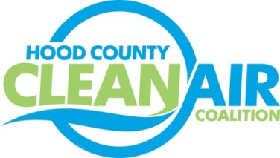
Meeting: Thursday, February 1, 2018
Cresson City Council Chamber
8901 E. US Highway 377 Cresson, Texas 76035
9:00-10:30 a.m.

Agenda

- Call Meeting to Order
- EPA Updates – Randy Pitre, EPA
- Local Updates – Michelle McKenzie
  - Review of January Meeting Summary
  - Report for DFWCC Idle Reduction Webinar
  - Review of Projects
    - Monthly Budget Review for December
    - Status of Projects FY 16/17/18
  - Alternative Funding Status
  - Filing of Annual Taxes
  - Ozone Advance Recommendations from EPA
- Regional Updates – Michelle McKenzie
  - Funding Opportunities, www.nctcog.org/aqfunding
  - DFW Clean Cities
    - Dallas-Fort Worth Clean Cities Events:
      - Clean Freight Solutions Meeting, February 13
      - Refuse Hauler Webinar, February 27
    - Dallas-Fort Worth Clean Cities Annual Survey
- Property Assessed Clean Energy (PACE) Presentation- Bridget Branch, Texas PACE Authority
- Other Discussion
- Adjourn

